

**Database theory 2dv513**

Assignment 3

Emil Mattsson EM222PI

Andreas Möller AM222XJ

Emil Bengtsson EB222SV

## Task 1: Idea - Library book loan database

Keep record of books, loans and borrowers for a library. And this should solve a problem of keeping track of book loans to borrowers. The main users of this system will be librarians at a library. Our idea is good for them because libraries needs to keep track of which book is loaned by which borrower. The system will include a table of books, table of loans and a table of borrowers. These tables will be connected by unique id's where loans, books and borrowers have unique id's.

## Task 2: Logical model

### E/R diagram

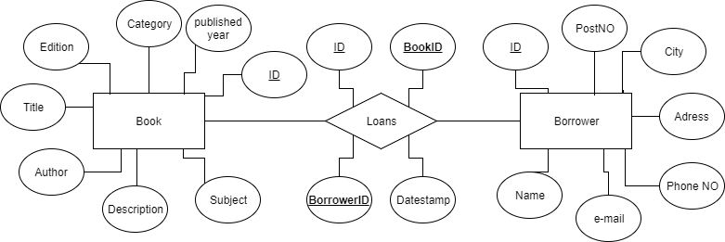

### Discussion

We identified several potential entities, but the E/R diagram above is the final result, and we thought it was good because it's simple and have the required entities and relation to make a good and simple database.

## Task 3: Design in SQL

### Relational scheme:

Book( ID, Author, Title, Edition, Published, Category, Description, Subject )

Loan( ID, **BookID**, **BorrowerID**, DateStamp )

Borrower( ID, Name, Address, PhoneNo, E-mail, City, PostNo )

We thought that "Loan" should have an own table like the entities "Book" and "Borrower".

## Task 4: SQL queries

CREATE DATABASE BookLoan;

CREATE TABLE Book (

Id INTEGER UNIQUE NOT NULL,

Title TEXT NOT NULL,

Author TEXT NOT NULL,

Description TEXT NOT NULL,

Category TEXT NOT NULL,

Edition TEXT NOT NULL,

Published DATE NOT NULL,

Subject TEXT NOT NULL,

PRIMARY KEY (Id),

);

CREATE TABLE Person (

Id INTEGER UNIQUE NOT NULL,

Name TEXT NOT NULL,

PhoneNo INTEGER NOT NULL,

Adress TEXT NOT NULL,

Email TEXT NOT NULL,

City TEXT NOT NULL,

Zip INTEGER NOT NULL,

PRIMARY KEY (Id)

);

CREATE TABLE Loan (

Id INTEGER UNIQUE NOT NULL,

BookId INTEGER NOT NULL,

PersonId INTEGER NOT NULL,

DateStamp Date NOT NULL,

PRIMARY KEY (Id),

FOREIGN KEY (BookId) REFERENCES Book(Id),

FOREIGN KEY (PersonId) REFERENCES Person(Id));

## Task 5: Implementation